Carti Hotel Management System

Use-Case Specification: Check-Out

Version <1.0>

Revision History

| **Date** | **Version** | **Description** | **Author** |
| --- | --- | --- | --- |
| 25/Nov/24 | 1.0 | Final Version | Hoang Sinh Hung |
|  |  |  |  |
|  |  |  |  |
|  |  |  |  |

Table of Contents

1. Check-out 4

1.1 Brief Description 4

2. Flow of Events 4

2.1 Basic Flow 4

3. Special Requirements 5

4. Preconditions 5

4.1 Administrator Authentication Succesful 5

5. Postconditions 5

5.1 Revenue Report Displayed 5

6. Extension Points 5

7. Prototype 6

Use-Case Specification: Check-out

# Display revenue report

## Brief Description

This use case describes the process of check-out and printing the bill for customers.

# Flow of Events

## Basic Flow

The workflow begins on the Receptionist Page, where the left panel displays functional buttons for key actions like Home, Reports, Check-in, Check-out, Manage Rooms, Manage Services, and Customers. The main section showcases the status of all rooms, color-coded for easy identification: green for "Vacant Ready," purple for "Being Cleaned," blue for "Stay Over," and grey for "Vacant Dirty."

The receptionist starts by entering a customer’s name in the search bar located at the top of the page and clicking the Search button. The system retrieves and displays a dropdown list of matching customers. The receptionist selects a customer, navigating to the Reservation Page, which displays the customer’s reservation details in blocks. Each block contains information such as room type, check-in and check-out dates, total length of stay, and price.

By clicking on a specific reservation, the receptionist is redirected to the Reservation Detail Page, where the bill is displayed in a detailed table format, including check-in and check-out dates, room charges, services used, and the total amount. Below the table, the Check-out Button is provided for finalizing the process.

Upon clicking the Check-out Button, the system updates the room’s availability and the customer’s reservation status in the database. The receptionist is then redirected to the Bill Information Page, where additional options are available to Print Bill, Save Bill, or Export Bill. If needed, clicking the Print Bill button generates a physical copy of the final bill for the customer.

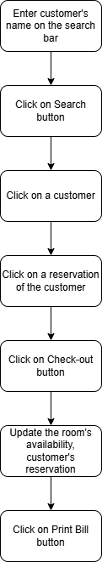

## Alternative Flows

None.

# Special Requirements

None.

# Preconditions

## Customer Active Reservation

The user has successfully logged in with the role of administrator.

# Postconditions

## Check-out Completed

The revenue report is successfully displayed on the Administrator Page.

# Extension Point

None.

# Prototype

The workflow begins on the Receptionist Page, where the left panel displays functional buttons for key actions like Home, Reports, Check-in, Check-out, Manage Rooms, Manage Services, and Customers. The main section showcases the status of all rooms, color-coded for easy identification: green for "Vacant Ready," purple for "Being Cleaned," blue for "Stay Over," and grey for "Vacant Dirty."

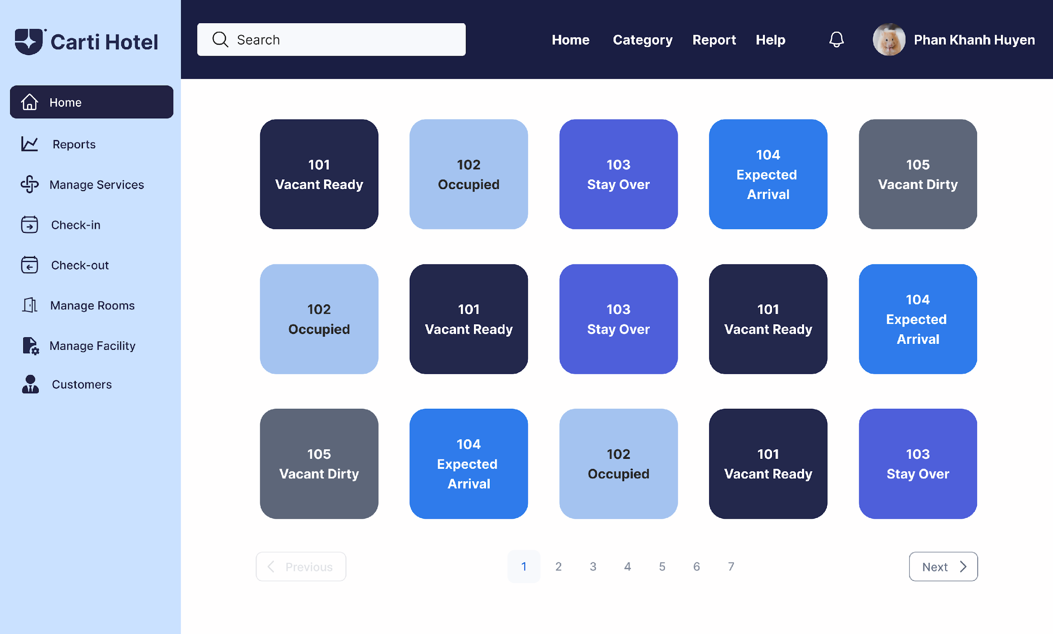

The receptionist starts by entering a customer’s name in the search bar located at the top of the page and clicking the Search button. The system retrieves and displays a dropdown list of matching customers.

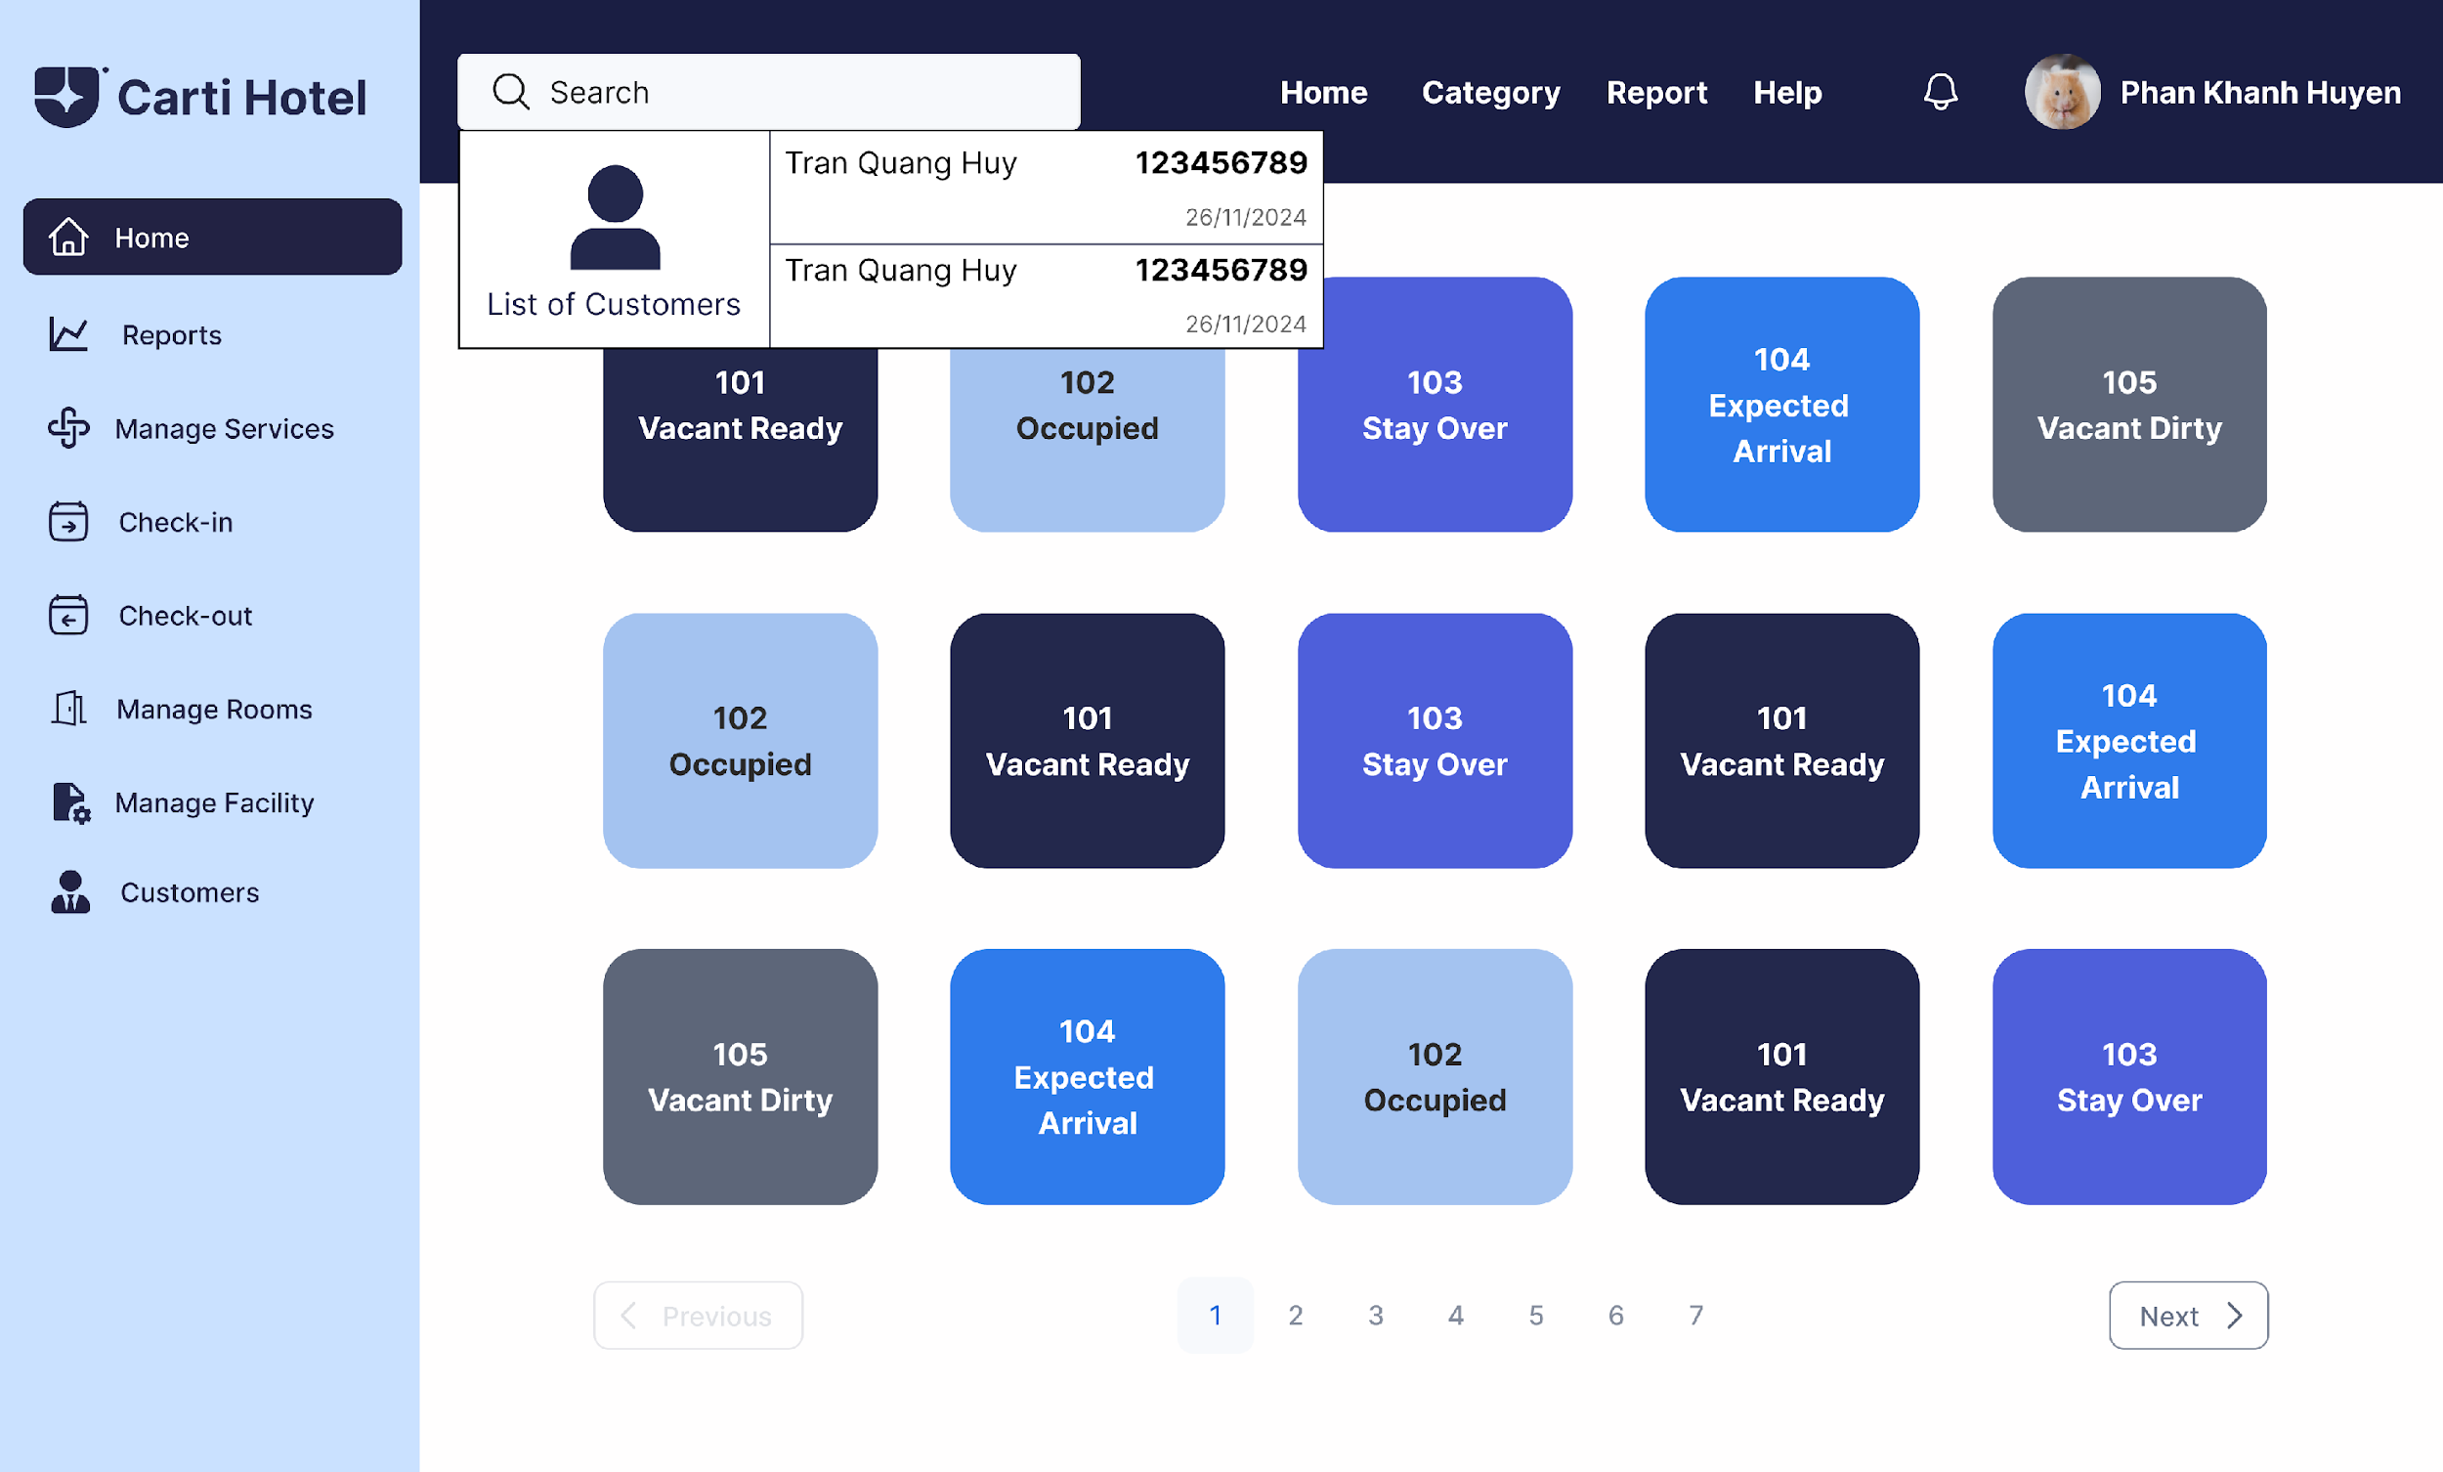

The receptionist selects a customer, navigating to the Reservation Page, which displays the customer’s reservation details in blocks. Each block contains information such as room type, check-in and check-out dates, total length of stay, and price.

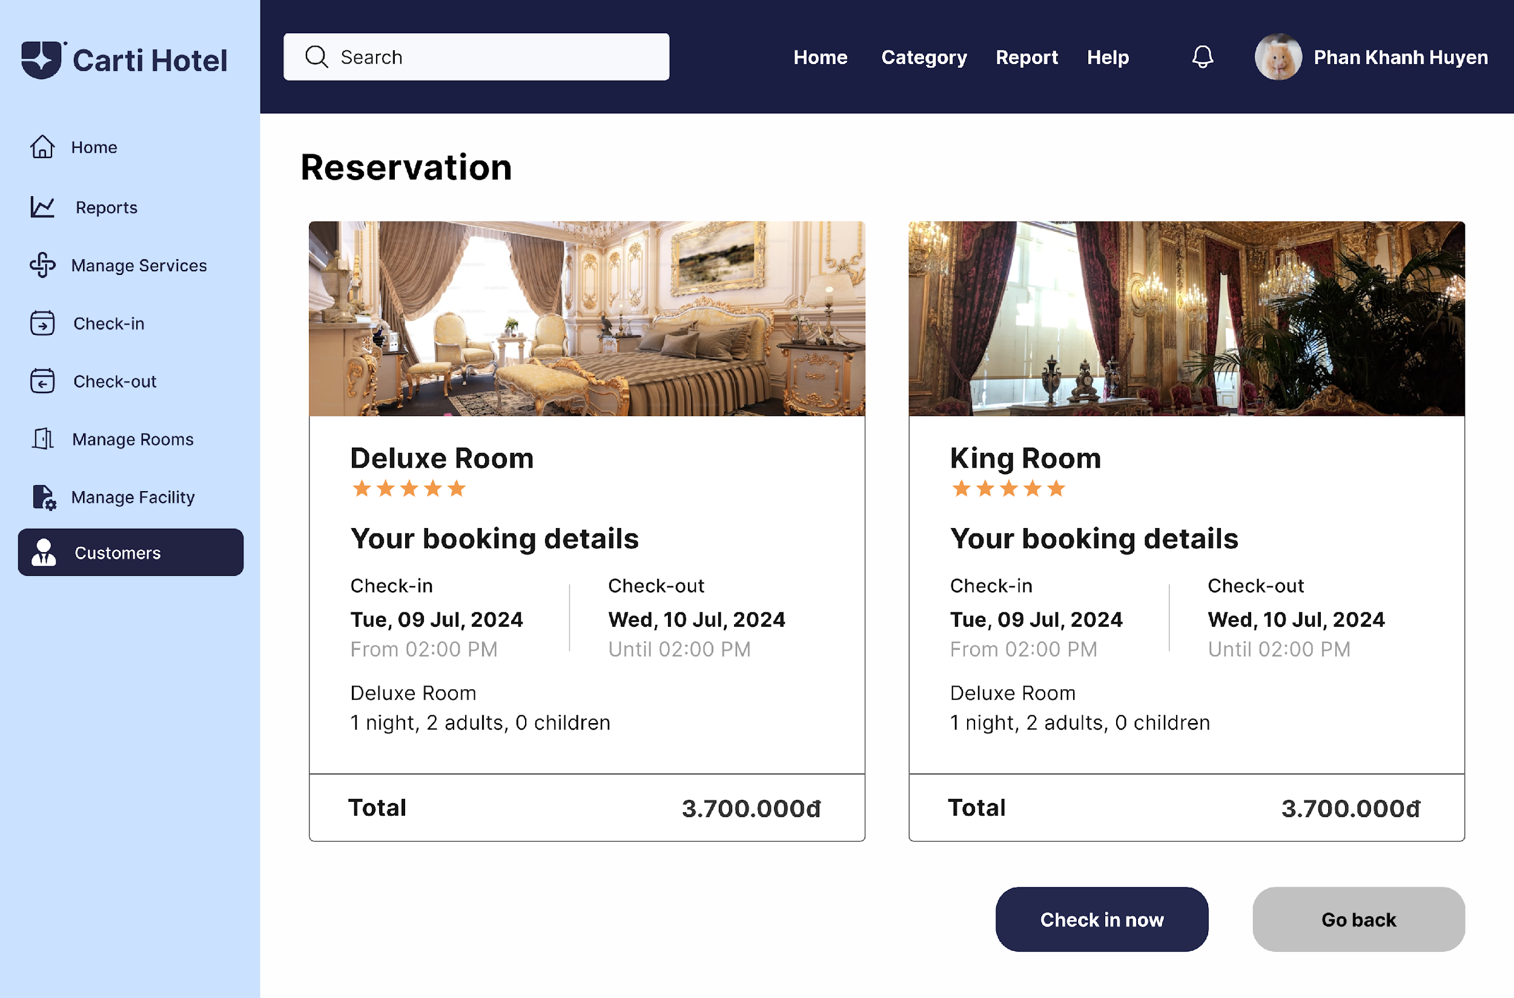

By clicking on a specific reservation, the receptionist is redirected to the Reservation Detail Page, where the bill is displayed in a detailed table format, including check-in and check-out dates, room charges, services used, and the total amount. Below the table, the Check-out Button is provided for finalizing the process.

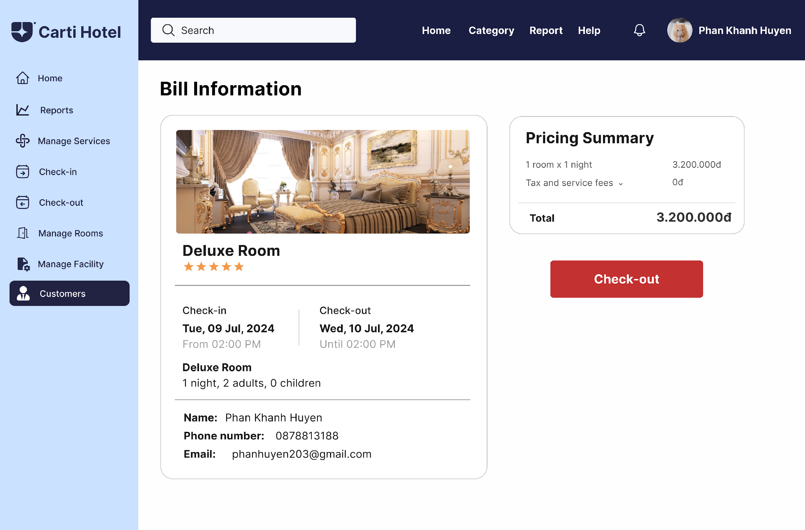

Upon clicking the Check-out Button, the system updates the room’s availability and the customer’s reservation status in the database. The receptionist is then redirected to the Bill Information Page, where additional options are available to Print Bill, Save Bill, or Export Bill. If needed, clicking the Print Bill button generates a physical copy of the final bill for the customer.

